1. First type “ git init “.
2. Then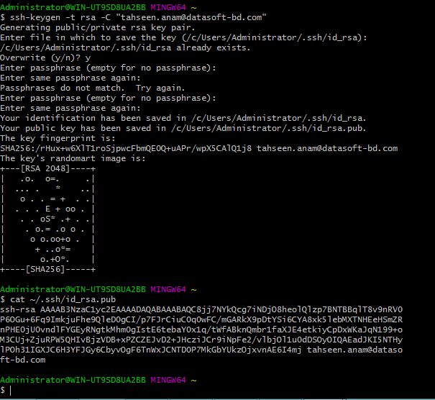
3. After that go to the git url, and generate a key with the generated key.
4. After that again type “ git init ”
5. Then